**Twitter Aggregation Solution – Sentiment Analysis**

HackSMU 2019

Yun Ho Jung

**?**

**Platform – Jupyter Notebook**

**API Used – Twitter**

**Logical Regression Data from IMDb**

Features

* Aggregates Twitter search data based on user query
* Through logical regression, predicts the ‘sentiment’ of the Twitter users’
* The training model is based on movie reviews from IMDB, consisting of 25,000 samples
* Weighted favorability of the search query is calculated and compared

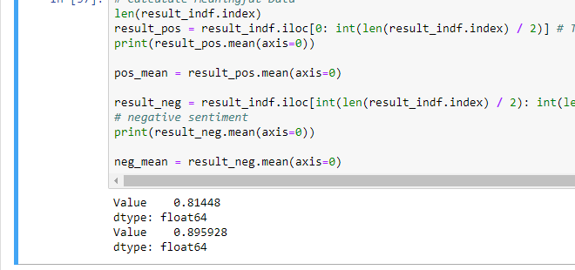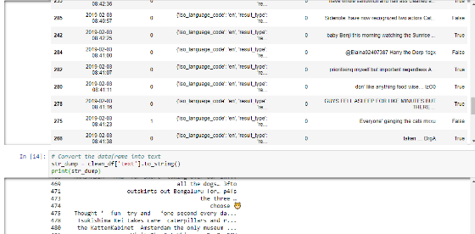Cleaning data before predicting

https://github.com/Dolcevice/TwitterAggregateSolution